**PARUL UNIVERSITY**

**Parul Institute of Computer Application**

**Basic Software Engineering – 05101253/05301253**

**Semester -4**

**Case Study Example: Surrounding Security System (SSS)**

**Practical 1:** Identify Project Scope & Objective

**Identify Project Scope & Objective:**

* Surrounding Security System (SSS) provides an interface for complain to Government in the different departments according to the type of Complain.
* Surrounding Security System can be used by any citizens of India who wants some improvement in our County.
* Surrounding Security System deals with all kind of issues like consumers complains, rake up complains, or any illegal activities.
* One Important thing first user have to register in the System. It will provide the System with fake user.
* For use Surrounding Security System user have to video record or voice record or take image of that illegal activity then he/she will upload that file in the System then they have specified that some options like which type of illegal media they have upload and they have to specify the place where media is made.
* User having also an option like if they want then they can mention their identity or they just left that column empty.
* Now system will send that media via mail to the Related Government Department. System will also send that media via mail to the Local and National Media.
* **Let’s understand with a simple example:**
* Let a User go to a Shop in Vadodara to buy a laptop. Let that Shopkeeper charging much money than the MRP. Then in that case user can Record Audio and then Click Picture of the Bill Receipt and the MRP which is Mentioned on the Box of laptop. Then user will attach all the file in the System and specify the Place as Vadodara and then he will specify the crime as Consumer issue then Click on Send. Now system will send that Media to Consumer Department of that State (Gujarat) and India, and at that time System will also send that media to Gujarat Local Media and National.
* System will also take care of user privacy by not involving any third person in the System for any task, System will do all task automatically.

**Modules & its descriptions:**

**1. Login Module**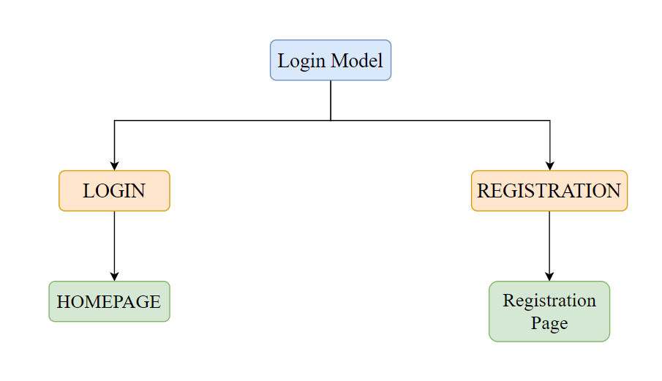

**Login:** This module enables user to Login or Register in the System.

**These are the sub modules of Login (main module)**

* 1. **Login:** Registered user can only login in the System.
  2. **Register:** Any user from India can Register in the System.

When Login module is executed then homepage will open and when Registration module is executed then Registration Page is executed.

* 1. **Login > Homepage:** After completing login it will go to the Homepage.
  2. **Registration > Registration Page:** After Clicking on Registration, it will be redirected on Registration Page.